Project Design Phase
Solution Architecture
Date | 16 February 2026
Team ID | LTVIP2026TMIDS66413
Project Name | Automated car catalog system for enhanced
Maximum Marks | 4 Marks

Solution Architecture:
The solution architecture defines the high-level structural design of the proposed system for optimizing user, group, and role management with access control and workflows. The architecture follows a modular, layered, and scalable web-based approach to ensure security, maintainability, and performance. It integrates user lifecycle management, Role-Based Access Control (RBAC), and automated approval workflows into a unified platform.
The system is designed using a three-tier architecture consisting of the Presentation Layer, Application Layer, and Data Layer. This separation of concerns improves system flexibility and allows independent scaling and maintenance of each component.
At the Presentation Layer, a responsive web interface is provided for administrators, managers, and end users. This layer handles user interactions such as login, access requests, role assignment, and dashboard visualization. The frontend communicates securely with backend services through RESTful APIs.
The Application Layer contains the core business logic of the system. It is responsible for authentication, authorization, workflow processing, role and group management, and audit logging. The RBAC engine within this layer evaluates user permissions before granting access to resources. The workflow engine automates routing of access requests to appropriate approvers and maintains approval history. Security mechanisms such as token-based authentication and session validation are enforced here.
The Data Layer manages persistent storage of all system information. It includes databases for users, roles, groups, permissions, workflow records, and audit logs. Proper indexing and relational mapping are used to ensure fast query performance and data integrity. Backup and recovery mechanisms are incorporated to maintain reliability.
Key architectural components include the User Management Module, Role and Group Management Module, Access Control Engine, Workflow Engine, Audit and Monitoring Module, and Notification Service. These components interact through well-defined APIs, enabling modular development and future extensibility.
From a deployment perspective, the system supports both cloud-based and on premise environments. The architecture is designed to handle increasing numbers of users and access requests without performance degradation. Security is enforced at multiple layers through encrypted communication, secure authentication, and strict authorization checks.
Overall, the proposed solution architecture provides a robust foundation for centralized access governance. It ensures streamlined administration, improved security posture, faster access provisioning, and full audit visibility, making the system suitable for modern enterprise environments.
Example - Solution Architecture Diagram:
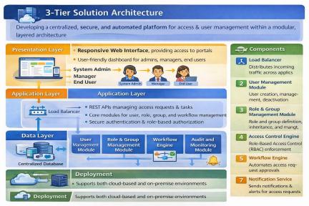
Figure 1: Architecture and data flow of the voice patient diary sample application
Reference: https://aws.amazon.com/blogs/industries/voice-applications-in-clinical-research powered-by-ai-on-aws-part-1-architecture-and-design-considerations/

